Sentry

# Introduction

Sentry is an error monitoring platform that enables developers to track and resolve problems in their applications. Python, JavaScript, Java, Ruby, and other programming languages and platforms are supported.

Sentry's key features include real-time error tracking, advanced filtering and searching, customizable notifications, and an easy-to-use web interface for error management. It also integrates with popular development tools such as GitHub, JIRA, Slack, and others.

# Project Summary

| Website | <https://sentry.io/> |
| --- | --- |
| Organization/Foundation Name | No specific organization/foundation |
| License | Apache License, Version 2.0 The MIT License (MIT)  Business Source License 1.1 (BSL-1.1) |
| Open/Proprietary | Open Source |
| Source Path | <https://github.com/getsentry/sentry> |
| Brief Description | It is a developer-focused error monitoring application that helps you find errors in your software code or application. |

# Project Details

## Key Features

* Sentry provides you with full-stack monitoring. It gives you clarity and visibility into your code, which will help you catch issues before they affect your software or cause downtime.
* Gives a readable and better view of the errors that are being faced by your application’s users.
* Helps you connect issues from the front-end to the back-end and helps you prioritize the fixes.
* All unhandled exceptions are automatically captured, with individual errors rolling up into larger issues.
* Can help you find and pick out errors in all major programming languages.
* Integrates hassle-free with major applications such as GitHub, Slack, Jira, Linear. Microsoft Teams, etc.

## Architecture

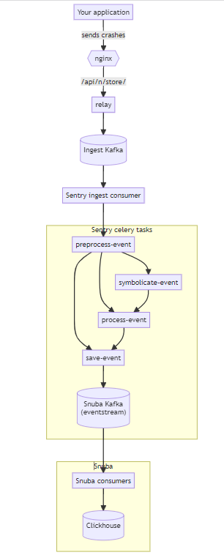

## Current Usage

It is currently being used by well-known and respected companies and organizations such as GitHub, Atlassian, Disney, Cloudflare, Microsoft, and Reddit.

## Project Comparison

### GlitchTip

* It is an open source software monitoring system.
* A one-stop solution for error tracking, performance monitoring, and site uptime checking.
* Compatible with Sentry client SDK but easier to run and entirely open source.
* It is not as accurate as Sentry.

### Rollbar

* This application collects all the errors that it finds in your application and notifies you so that you can solve it.
* Can be used for a lot of programming environments, but not as much as Sentry gives.
* Sentry provides real-time updates and gives you the complete context of the errors.
* Sentry integrates in a lot more places than Rollbar.
* Sentry meets the needs of an organization better than Rollbar.

### New Relic

* APM, K8s monitoring, ML Model Monitoring, Log Management, Synthetics, and other monitoring services are all provided by New Relic.
* Their Application Performance Monitoring provides the majority of the capabilities you'd anticipate from such a well-liked APM monitoring tool, and it enables you to traverse and see your stack.

### Raygun

* You may track the performance and defects of JavaScript web apps with Raygun, and it also gathers information for more thorough diagnostic and performance analysis.
* Raygun easier to use and set up. However, Sentry is easier to administer. Sentry is overall preferred over Raygun.

# Reference/Acknowledgements

<https://develop.sentry.dev/>

<https://sentry.io/for/full-stack/>

<https://sentry.io/>

<https://docs.sentry.io/>

<https://betterstack.com/community/comparisons/sentry-alternatives/>

<https://alternativeto.net/software/sentry/?license=free>

<https://www.g2.com/compare/raygun-vs-sentry>

<https://www.trustradius.com/compare-products/new-relic-vs-sentry#best-alternatives>

<https://sentry.io/integrations/>

<https://develop.sentry.dev/docs/>

<https://open.sentry.io/licensing/>

<https://develop.sentry.dev/architecture/>